“Witnessing and dealing with the effects of drug-related violence in Northwest Mexico”

Valente Soto
School of Geography and Development
University of Arizona

The aim of this research is to identify the means by which professionals—psychologists, social workers, and journalists—who witness or in-directly experience the effects of drug-related violence perceive and develop mechanisms to cope with its growing prevalence in Sinaloa, Mexico. The research explores the role of affect, emotions, and memory in the creation of those mechanisms and seeks to understand how the urban landscape both shapes and is shaped by responses to drug-related violence. During the two months in Culiacan from July the 6th to August the 11th, I did twenty semi-structured interviews: 7 journalists, 7 psychologists, and 6 social workers. I did archival research and took detailed field notes on my observations of the daily life and the local environment of Culiacan, as well as on the informal conversations that I had with ordinary citizens, family members, friends, and governmental workers. I also met with faculty and graduate students from the School of Psychology of Universidad Autonoma de Sinaloa that are doing research on the intersection of drug-related violence, culture, and social memory. This was a great experience as they provided me feedback, contacts, and suggestions on how to continue developing my research. One of the main opportunities that resulted from these meetings is the possibility to create a research network of scholars working on these topics and organize a public forum where different scholars will present their works in order to start a larger conversation among the public society and the different local actors. I am particularly interested in collaborating in the research project on “Social Memory and Operation Condor in Sinaloa” that is directed by Dr. Tomas Guevara.

Doing fieldwork in my hometown was an interesting and complex experience. The first challenge was to make contact with the different professionals, particularly with the journalists because they are working in a difficult and dangerous environment that makes them a closed circle in which you need referrals in order to get an interview. Journalism in Sinaloa is an activity that faces different kinds of censorship and pressures from the drug cartels and the different levels of government. During my stay, the Congress of Sinaloa approved a new law that severely restricted the access to information and the work of journalists as they were limited to get crime information only through official government press releases and journalists were banned from inspecting the crime scene, recording audio on site, taking testimonies, photographs and/or video. In response, journalists, local media, scholars, NGO’s and public society organized a public manifestation (see attached pictures) that took place on August the 7th, 2014. After my return to Tucson, the law was reformed on August the 21st and the Congress removed Art. 51 Bis that was the most controversial. Still, journalists continue to fight censorship and threats from the government and the criminal organizations. In the case of psychologists and social workers, the main challenge was to get the authorization from their workplaces as the government of Sinaloa is trying to control who has access to information and contact with people involved either with witnesses or victims.
Preliminary findings suggest that psychologists and social workers are more susceptible to experience some of the symptoms of Secondary Traumatic Stress Disorder (STSD), while journalists experienced different effects that are not necessarily related to STSD and that I identify as Narco-trauma. STSD is also known as compassion fatigue. According to Charles R. Figley, STSD is an emotional and behavioral condition that results from working with victims and knowing about a traumatizing event experienced by a significant other. The resulting stress is a product of the help or desire to help a traumatized or suffering person.
STSD is a syndrome of symptoms nearly identical to Post Traumatic Stress Disorder (PTSD), except that exposure to knowledge about a traumatizing event is different. Among the symptoms experienced by psychologists and social workers are: recollections of event and/or traumatized person; efforts to avoid thoughts and feelings; efforts to avoid activities or situations; diminished interests in activities; diminished affect; and hypervigilance. In contrast, journalists experienced similar and other effects that result from a closer distance with the place where a violent event occurred and a more ephemeral contact and interaction with the victims or witnesses. Some of the symptoms experienced by journalists are: recollections of events that are triggered by the landscape; dreams of events; efforts to avoid thoughts and feelings; fear and anger; diminished affect; difficulty falling asleep; and hypervigilance. I identified this symptoms as narco-trauma as it results from the relationship with place, the objects and the images and not so much from working with victims or traumatized persons. Moreover, it seems to me that narco-trauma could be experienced by any person who has witnessed the multiple forms and expressions of drug-related violence taking place in Mexico and other parts of Latin America.

The findings from this exploratory research are essential for the development of my dissertation and significantly contributed to my academic career as it opened new opportunities for interdisciplinary and transnational collaboration. I will continue to do research on this topic and the results will be used to submit a new research proposal for the Drugs, Security and Democracy Fellowship of the Social Science Research Council. In addition, I will present the findings next year at the Annual Meeting of the Association of American Geographers in Chicago and I will write a paper to submit for publication to the Journal of Latin American Geography. Funding from CLAG Field Study Award was used to acquire recording equipment, data analysis software and cover part of the travel and research related expenses. Finally, I would like to use this opportunity to express my gratitude to CLAG for its’ support as it was essential to materialize this exploratory study.

Photos
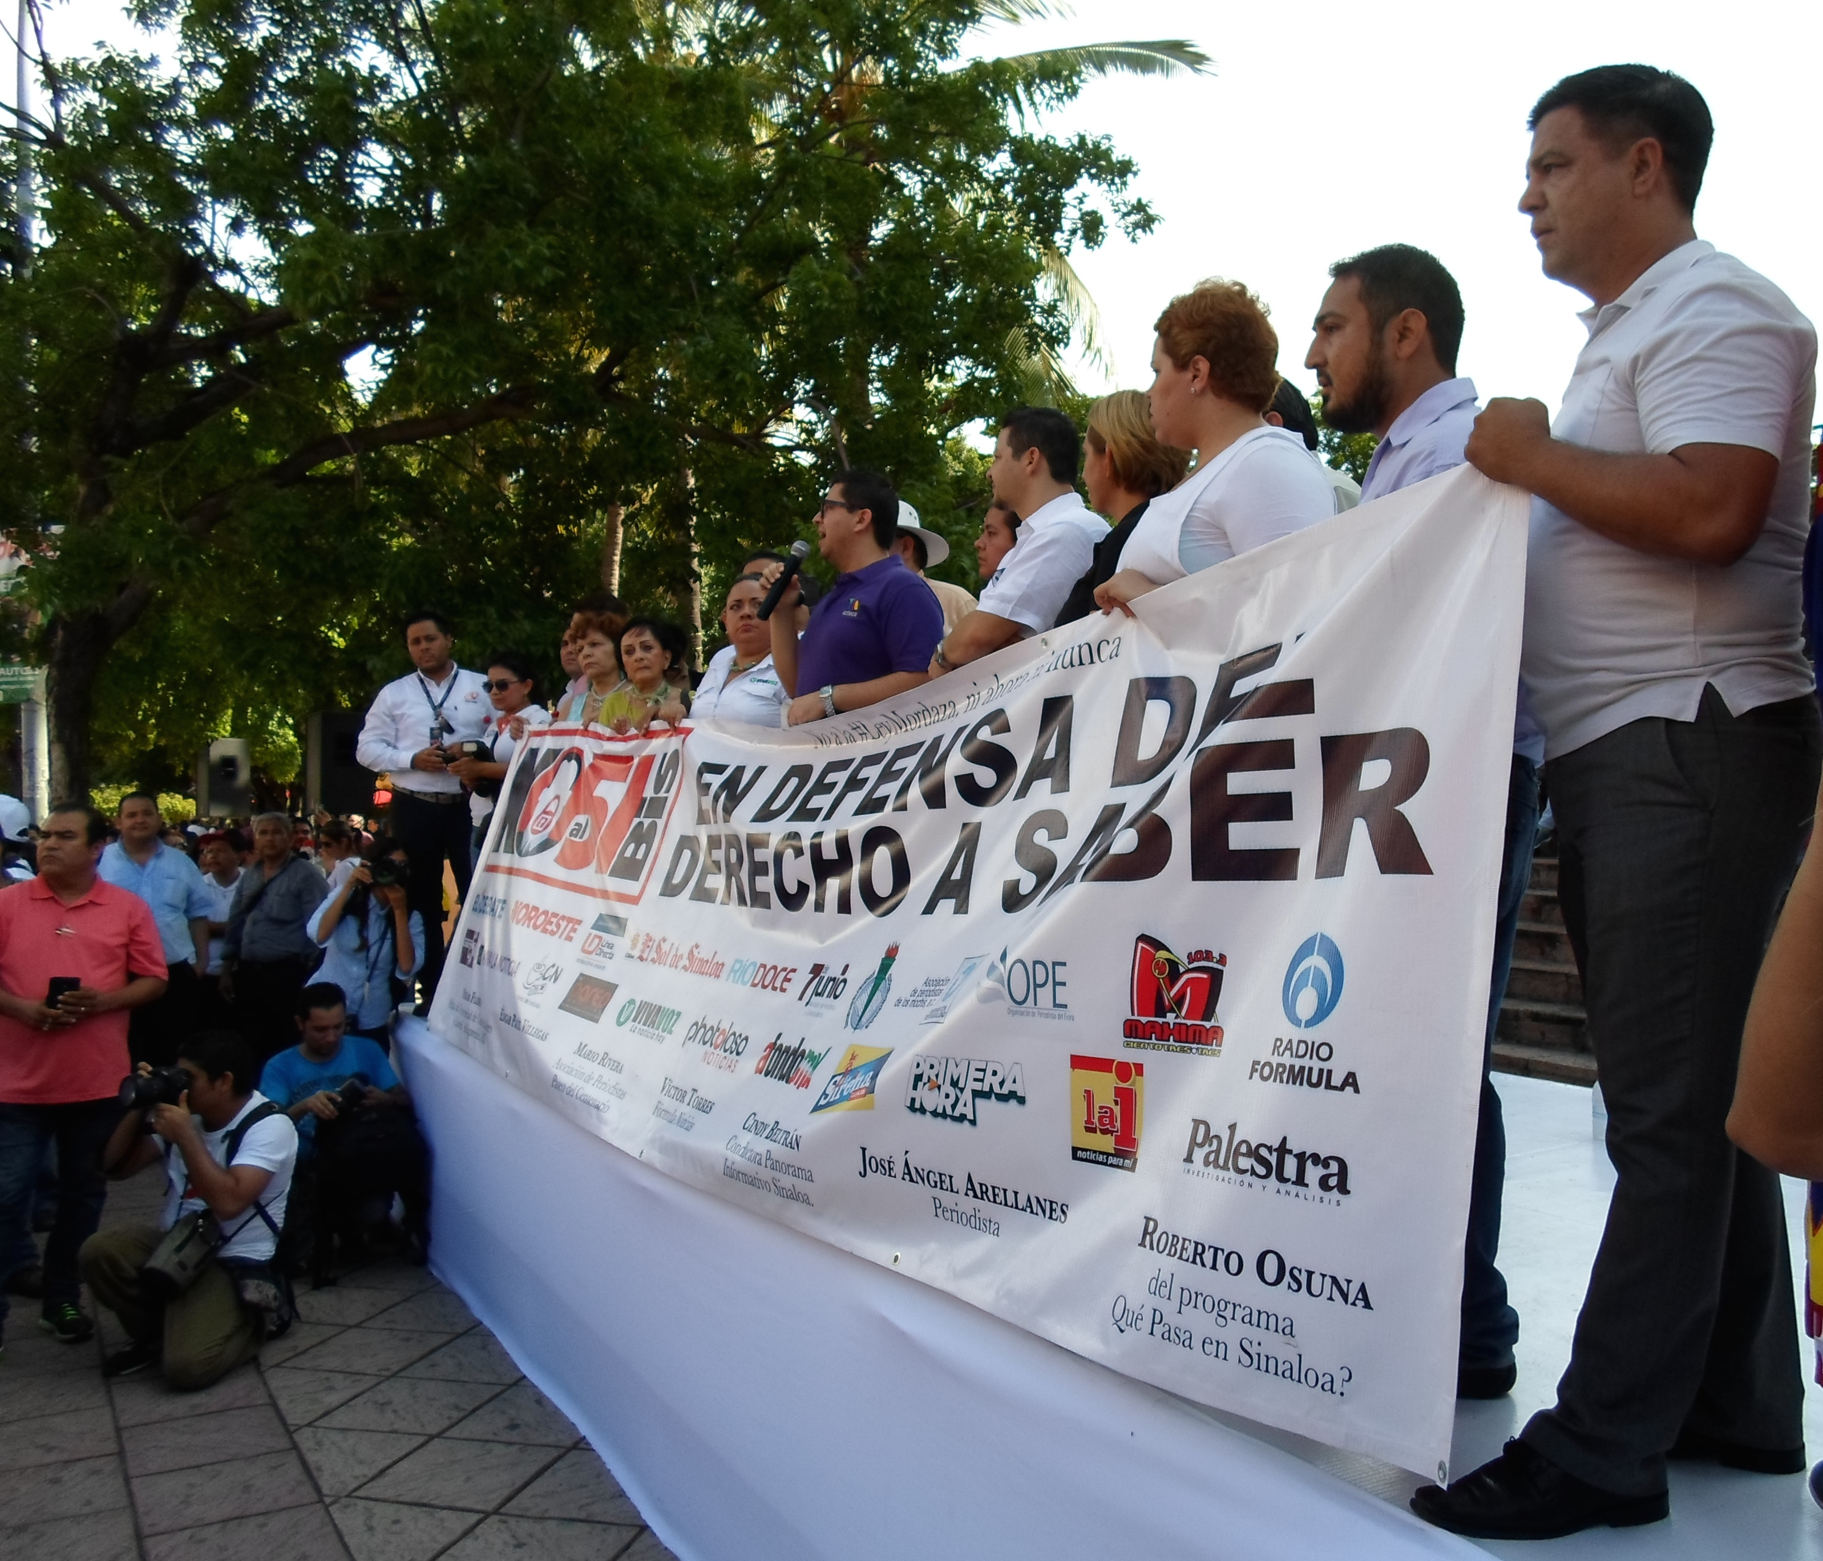
Figure 1. On August the 7th, 2014 local media, professional associations, academics, and civil organizations organized a public manifestation against the approval of the new law. In particular, against Art. 51Bis that severely restricted crime coverage and the access to information.

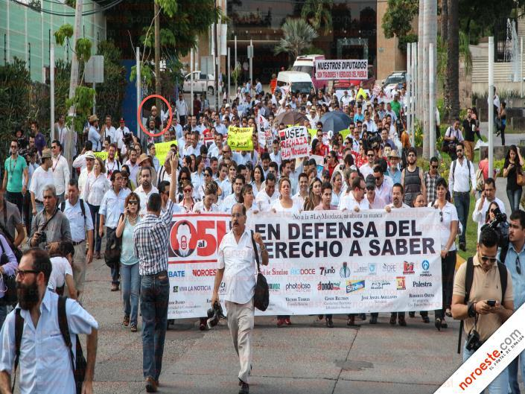
Figure 2. Noroeste.com is a local newspaper that published this photo of the public manifestation. I am the one in the red circle and I attend this event to make new contacts and do some interviews on the impact of the new law over journalism and the search for justice in Sinaloa.

