Sarah Kelly-Richards
School of Geography and Regional Development
University of Arizona
shkelly@email.arizona.edu
CLAG Final Report
Contested Territories and the Changing Hydropower Landscape of Southern Chile
6/24/14 – 8/14/14

Contested Territories and the Changing Hydropower Landscape of Southern Chile

Funding from the Conference of Latin Americanist Geographers supported preliminary dissertation research in Chile this summer, which proved to be rich with experiences and findings. While I set out to examine a broader range of water conflicts, initial interviews in Santiago re-focused my attention on emerging hydropower conflicts in southern Chile in the Ríos and Lagos regions. In this area of southern Chile, private companies, with little regional-level coordination, are developing an unparalleled number of large and small dams. This surge in hydropower development is resulting in legal disputes – concerning community consultation, property rights infringements, and ecological harm – as well as alternative land zoning strategies promoted by tourism consortiums and indigenous peoples among others.
Overall, I conducted thirty-five semi-structured interviews with policy actors, nonprofit organization employees, academics, and local stakeholders, including tourism consortiums and indigenous people from the Mapuche nation. What struck me during interviews in Santiago and southern Chile is that actors from many different sectors desire more integrated planning for hydropower dam development. In response to calls for policy changes, Chile’s Ministry of Energy is forming an energy agenda that incorporates land-use planning and private-public dialogue. However, the potential of these policy changes will be important to assess within Chile’s existing institutional design for water and energy governance. Currently, the institutional framework for water and energy governance cannot adequately address the tensions produced by hydropower development.
My research experiences this summer compel me to ask the following questions for my future dissertation research: 1) What are the legal barriers to and policy changes capable of creating more equitable planning mechanisms for hydropower development? 2) Why and how are local groups coordinating alternative proposals for resource management to contest hydropower planning in the Ríos and Lagos regions? My driving questions as well as research approach reflect input I received from local stakeholders as well as policy actors. To answer these questions, I will employ a set of qualitative methods, including 1) participant observation, 2) semi-structured interviews, 3) legal and policy analysis, and 4) archival research.
After arriving in Chile, I spent nearly three weeks in Santiago interviewing government employees, academics, and nonprofit personnel while also attending a water management workshop. While there, I also conducted online research of environmental laws, legislative proceedings, and ongoing social movements related to water-energy governance. From Santiago, I headed south to Valdivia in the Ríos region. There, I met with researchers at the Universidad de Austral as well as indigenous leaders and environmental consultants and activists. The next three weeks I traveled throughout the Ríos and Lagos region, visiting proposed dam sites and speaking with affected people as well as related researchers and professionals. Returning to Santiago, I met with affiliate sponsors for future research, attended a one-day political ecology conference, and conducted follow-up interviews.
Drawing from scholarship on the political ecology of territorialization and environmental governance, my future research agenda aims to be policy relevant while also cognizant of competing visions for landscape and resource planning. Where these processes are incompatible, I will highlight the conceptual and legal barriers and what conclusions this leads me to draw about Chile’s market-based environmental governance framework. Chile is at an important political moment, with potential changes to the legal water framework, as well as policy changes to hydropower development and environmental impact assessments for hydropower infrastructure. Moreover, the process of consultation with indigenous groups in hydropower infrastructure development is highly contested, with legal disputes challenging the commitments Chile made when it signed ILO Convention 169. Research that assesses in what ways national environmental policy and regional governance dynamics are mutually constitutive could inform these environmental governance changes.
My research now seeks to understand the unfolding socio-ecological landscape of small and large hydropower dam development in the water abundant Ríos and Lagos southern regions of Chile. This will build on my previous intention to conduct an institutional ethnography of water governance. However, the focus on hydropower redirects my attention to study the environmental impact assessment process and integral planning being promoted by the Ministry of Energy. I will complement this policy study by observing and interviewing members of two movements to stop or alter the course of hydropower development in these regions. Crucially, both of these movements propose alternative visions for delineated territories based on values that do not fit into a market-based legal environmental framework. Additionally, the advent of small hydropower dams is articulating with technological development and social resistance processes in new ways. Consequently, I plan to assess how the development of these dams articulates with climate and energy policy and socio-territorial processes.
Support from the Conference of Latin Americanist Geographers has significantly advanced my dissertation research. I have begun preparing larger dissertation grant proposals for submission this fall and winter. I will take my comprehensive exams in Spring 2015, hopefully heading back to Chile for a year of dissertation research starting mid to late Summer 2015. This support also allowed me to build relationships of trust and exchange with researchers, activists, and policy professionals, which will hopefully lead to longer-term collaborations. In a broader sense, this marked an important step toward my becoming a professor, as it lay the groundwork for an exciting, and hopefully, successful dissertation research experience.
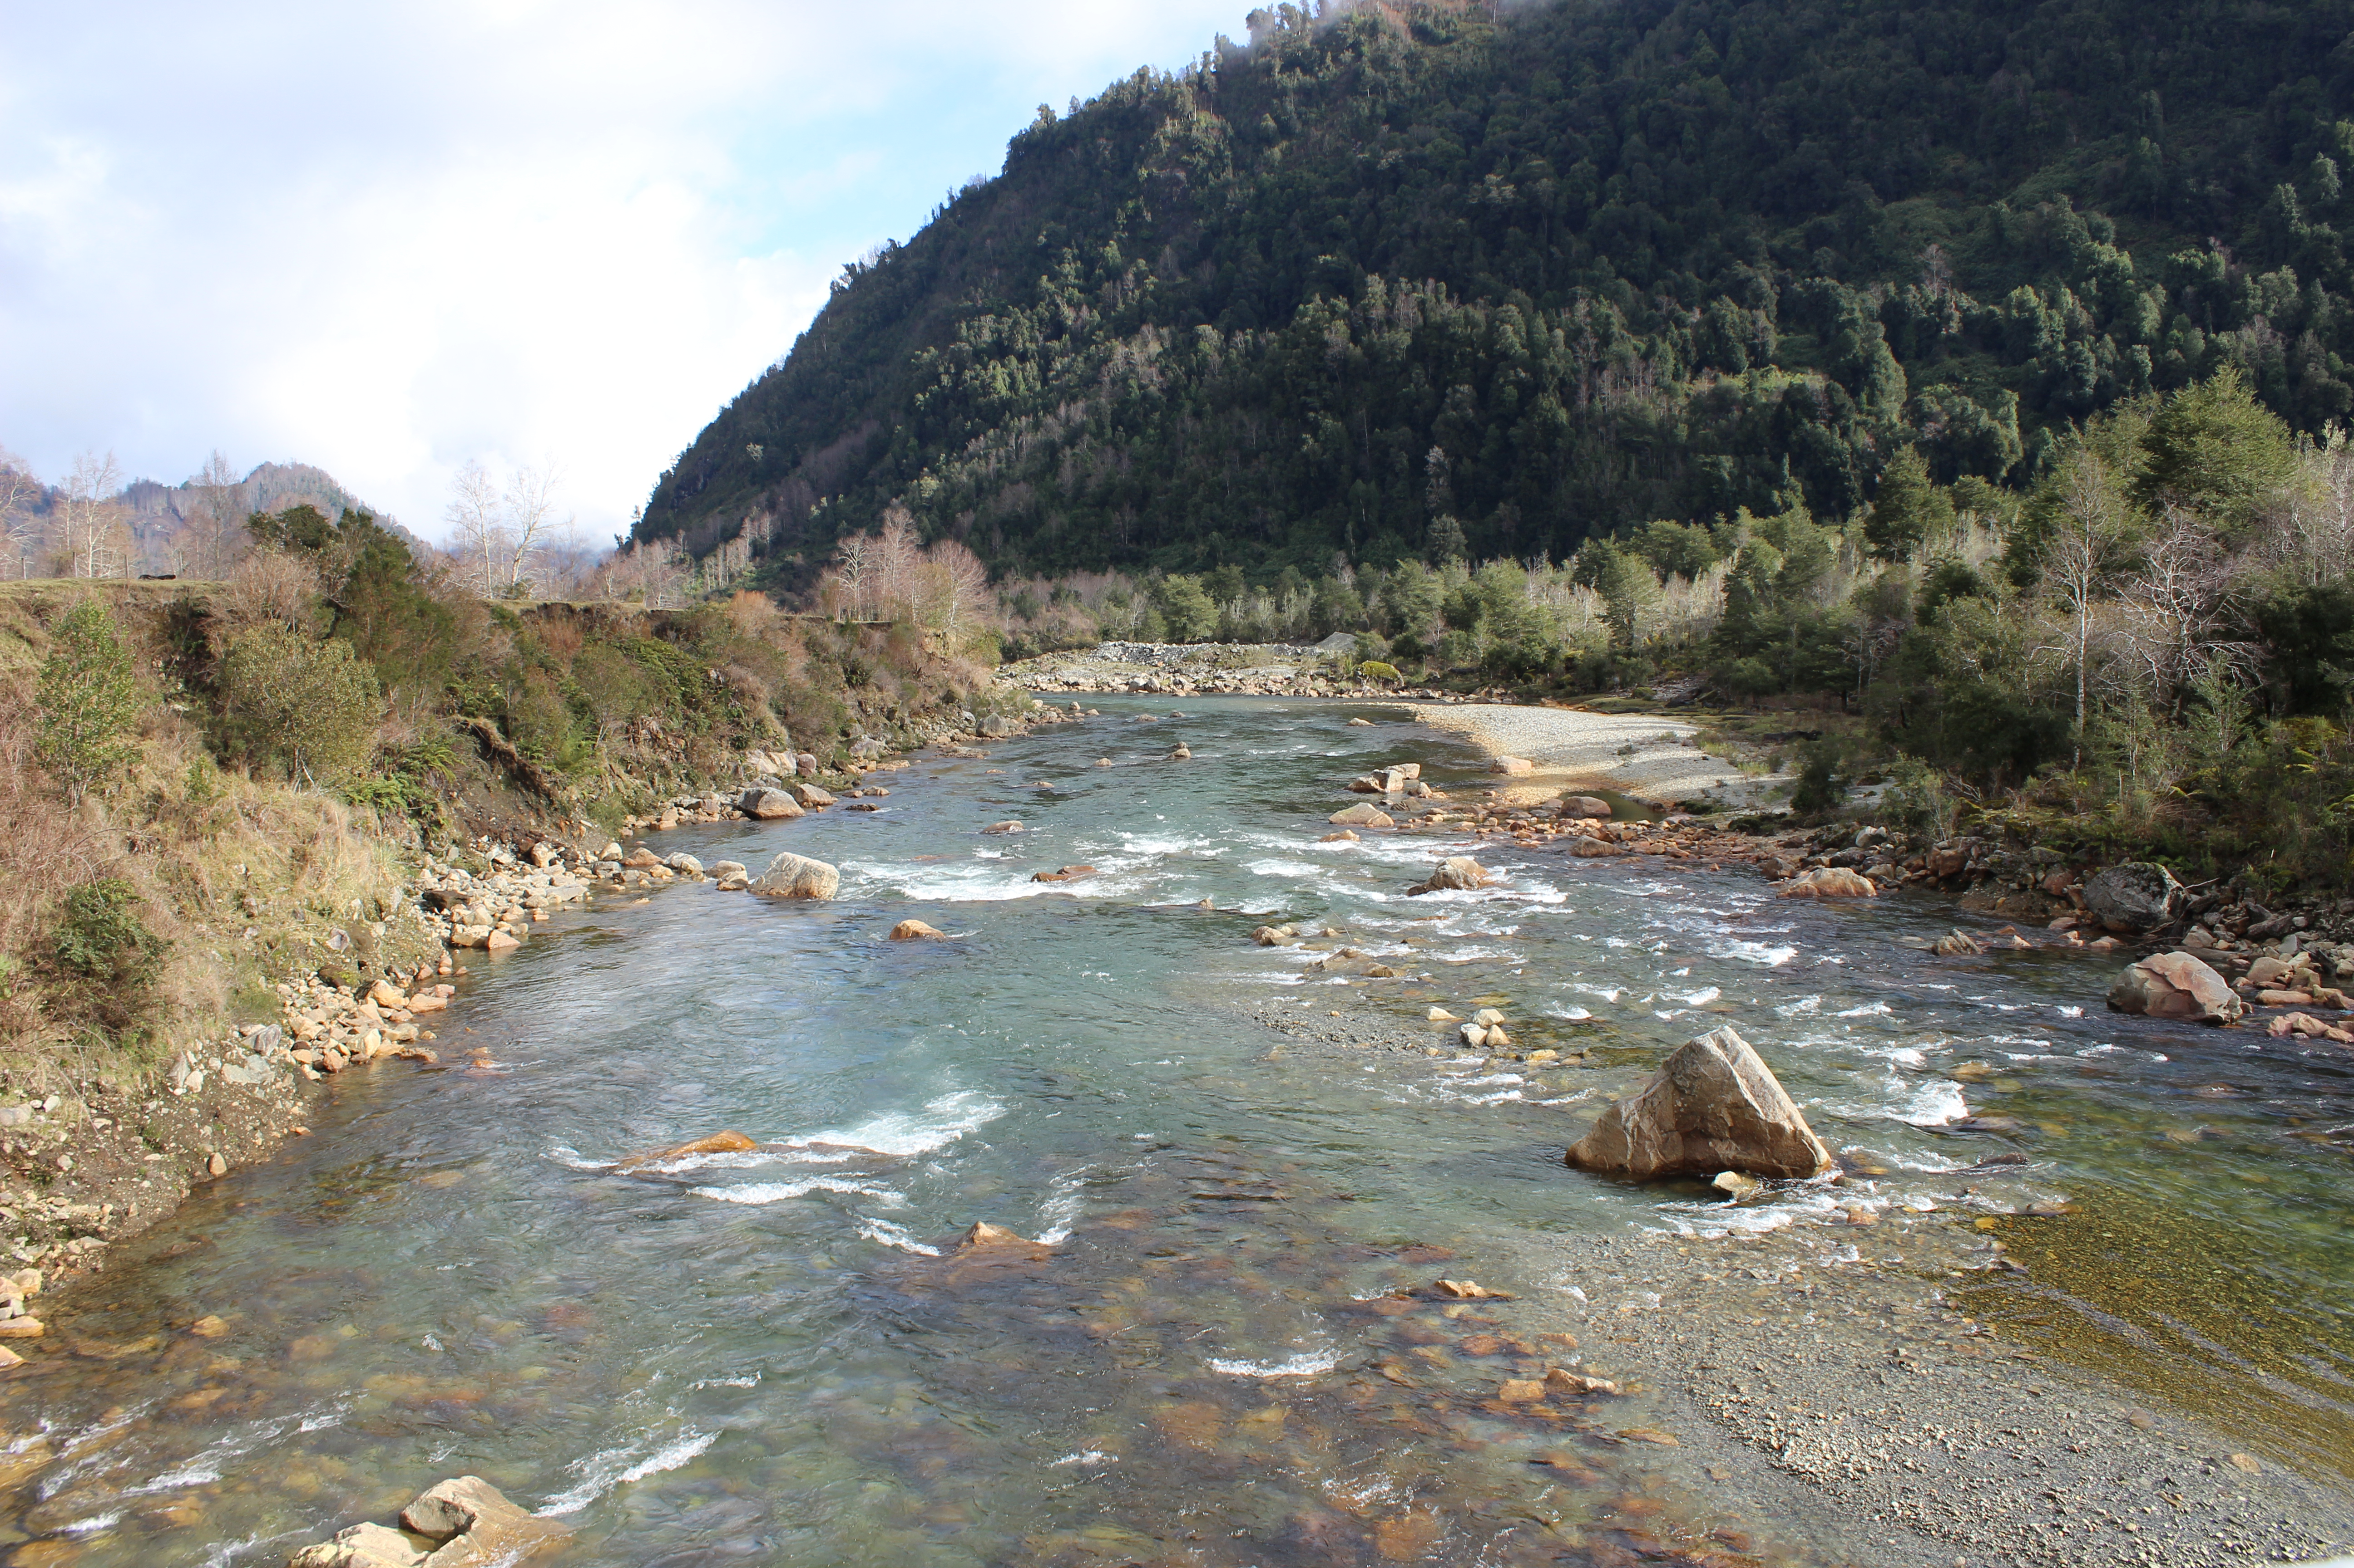
One of the rivers slated to be dammed in the cordillera of the Ríos region of Chile.

I changed the title of my research to reflect preliminary findings. I am fine with using the old title in the Clag newsletter is that is preferable, but I felt this title more accurately describes my future research direction.
Bauer, C. J. (2009). Dams and markets: Rivers and electric power in Chile. Natural Resources Journal,49(3), 583.
Vandergeest, P., & Peluso, N. L. (1995). Territorialization and state power in Thailand. Theory and society, 24(3), 385-426.

